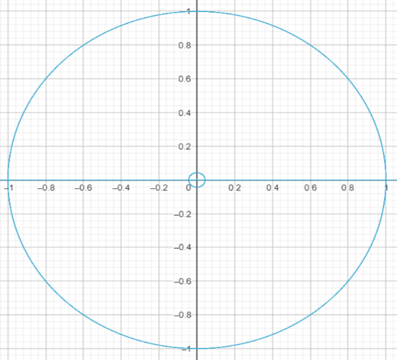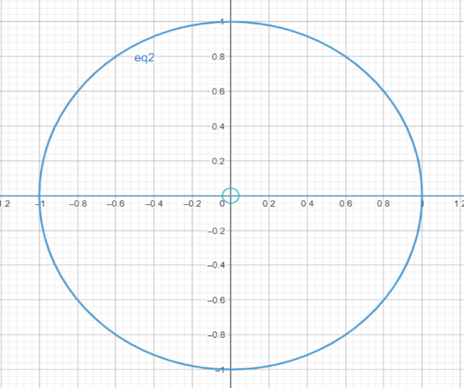1 - Unit Circle is equivalent to imaginary unit Circle

2- In imaginary unit circle

3- In non-Imaginary unit Circle

As we did in imaginary unit circle; any complex number to be at [i], we divide pi by two. And pi is a ratio to the circle circumference.

So, we are going to do the same for non-Imaginary unit circle we are going to divide by two. Division will be at 45 degrees. And this degree in imaginary unit circle will be at

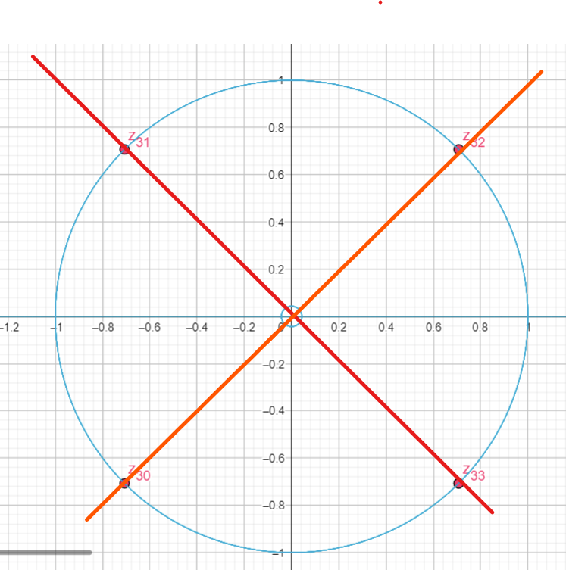

We are going to use small trick we are going to define function to represent this division in term of imaginary unit circle using this formula

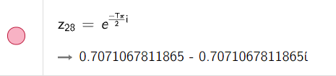

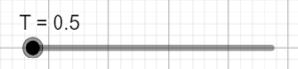

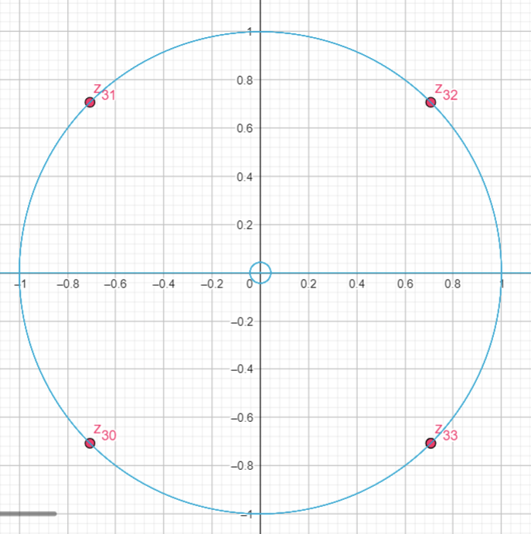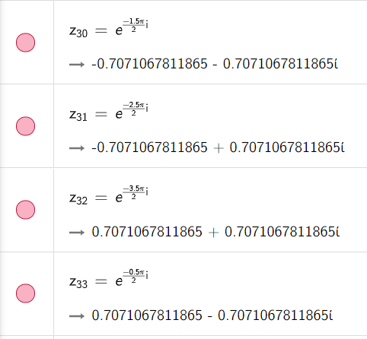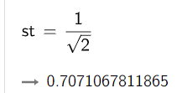

Square root of two comes from the non-imaginary unit Circle , and of course from Cos(45) and Sin(45) in imaginary unit Circle.

To divide something on equal parts you need one point to start division on and end division at every time you do one full rotation on the non-imaginary unit circle.

We are going to introduce a new formula to find this start point for division for any natural number.

We can convert these formula

Example (1): D = 2; we Divide Circle by 2 \* 2

Applying the formula so we get these points with step difference = 4.

One note here the values of the formula will be start point { +2 , +4 , +6 ,+8 , +10 , +12, ….}

Where start point in this example is g1 = 0.5.

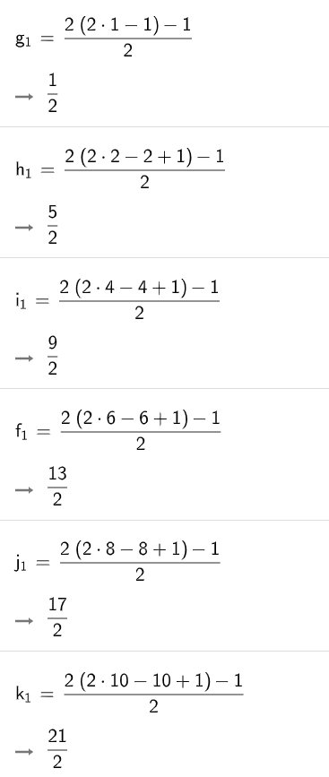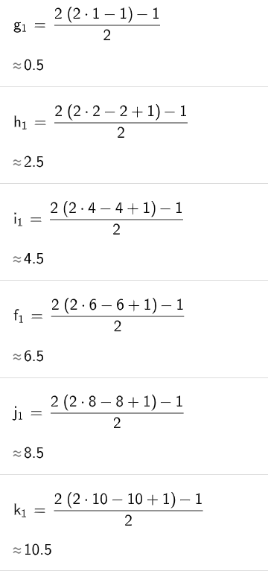

In imaginary unit Circle the start fixed point will be at

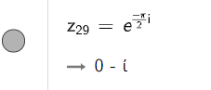

And every 4 steps we are going to go back to this exact imaginary point gain after one full circle on the non-imaginary Circle

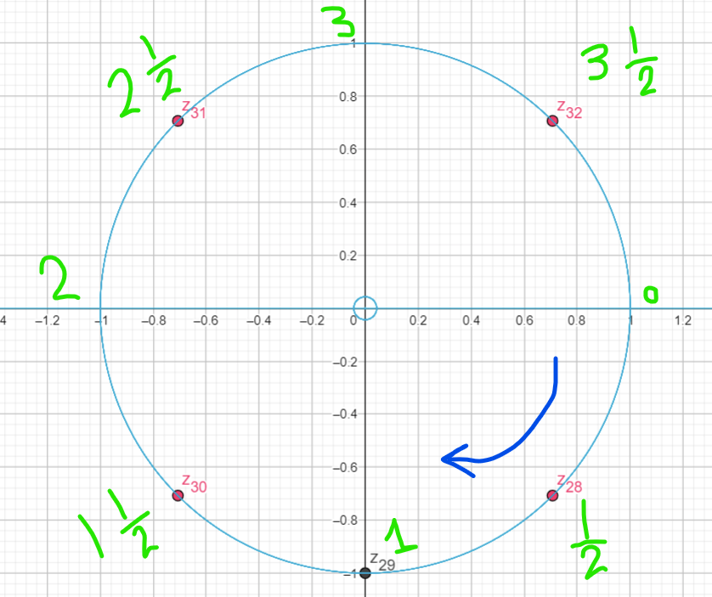

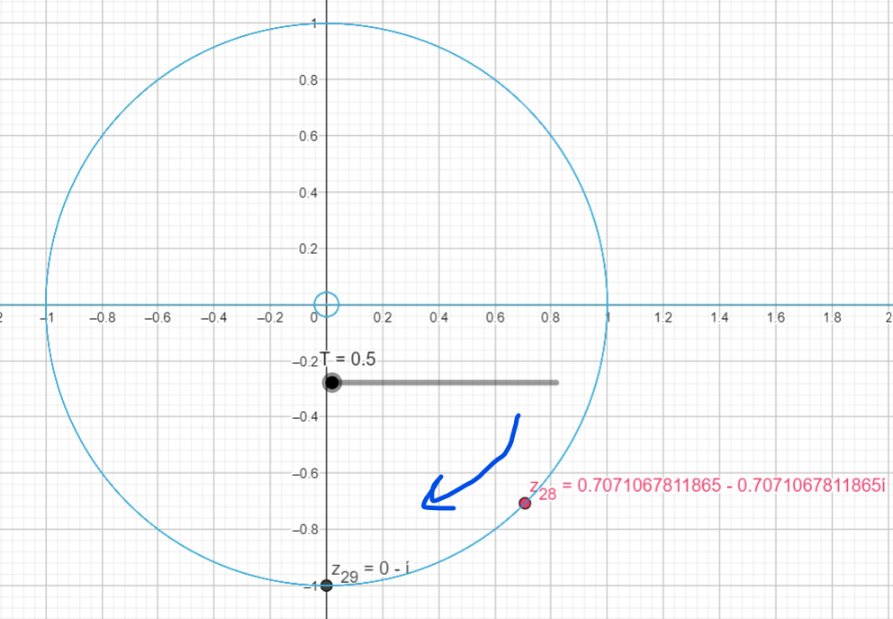

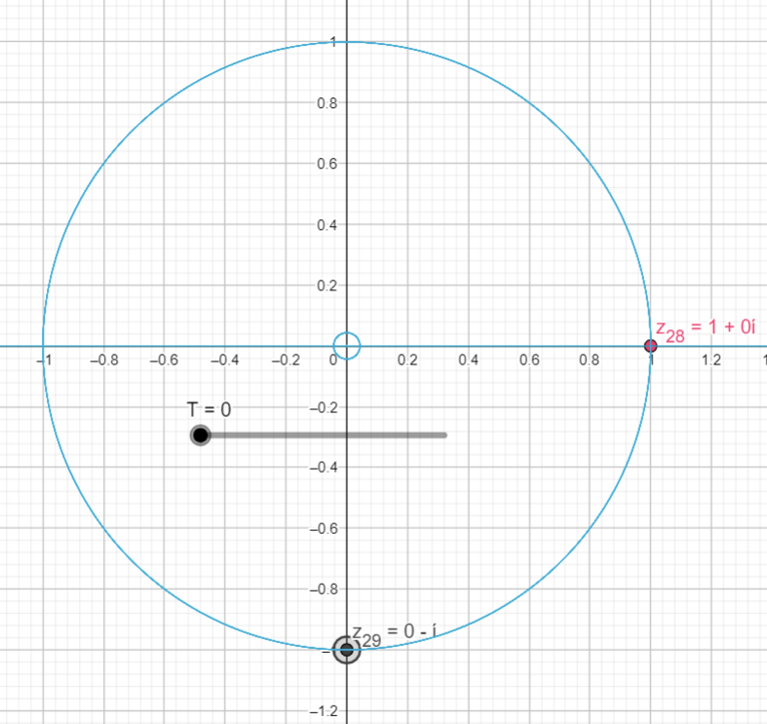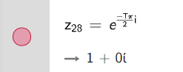

Will reach exact start point (Z29) for division with D = 2 at our formula (g1) fraction nominator value

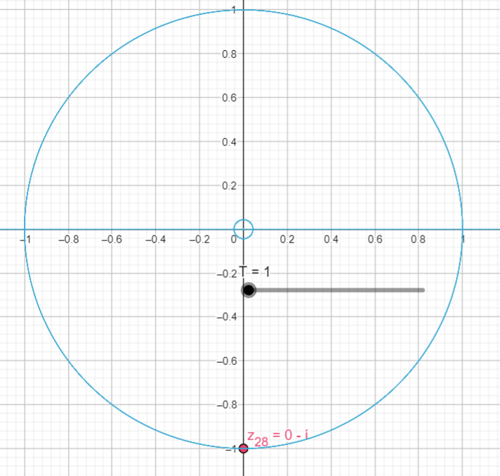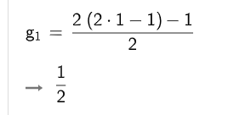first time we will pass over imaginary point (Z29), our division start point, will be at T =1 (nominator of g1 = 1)

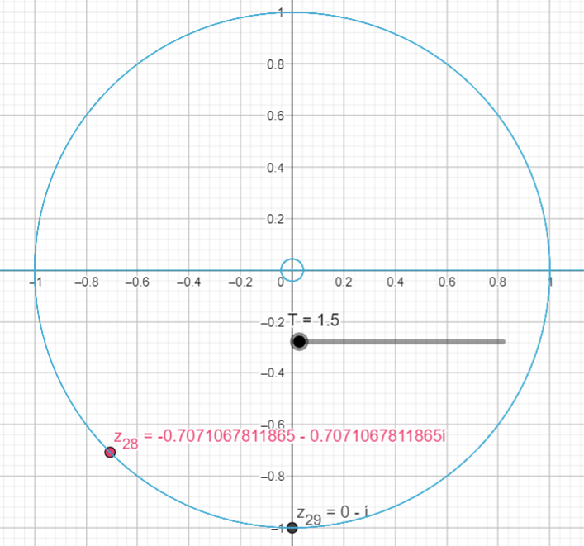increasing T by 0.5 will make us move away from start point Z29 at T =1.5 and we keep moving over the Circle circumference until we reach the second formula nominator h2 (i.e., we reach T = 5 as h2 = 5/2)

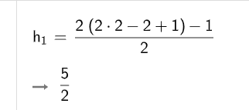

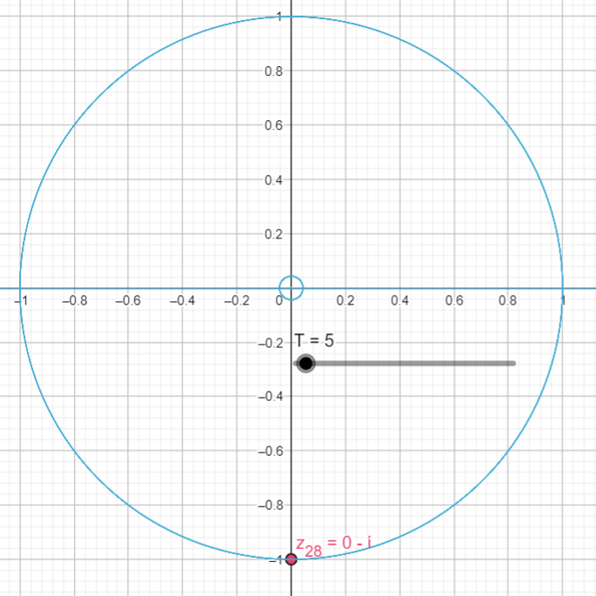

And we keep rotating around the non-imaginary unit Circle and the next time we pass imaginary point (Z29) at T =9

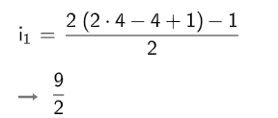

Next time at T = 13

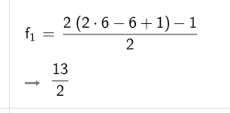

Next time will be at T = 17

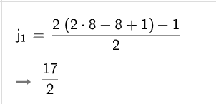

Next time will be at T =21

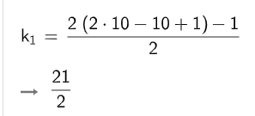

So, starting from [start point (Z29) – D divisions]; i.e., two steps before the start point Z29 as D in this example =2; so, after the first start point, we are going to increase T by 4 as our nominator will increase by 4 each full cycle.

Another note here both formulas are equivalate to each other 2 \* (3 \*N -N +1/2)

Equivalent to (2 \*N - N +1)

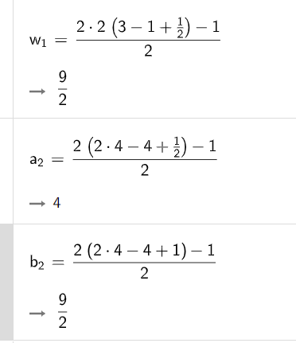

Example (2): D = 4; we Divide Circle by 2 \* 4 = so one cycle step to reach same start point will be = 8

Applying the formula so we get these points with step difference = 8.

One note here the values of the formula will be start point {+2, +4, +6 ,+8 , +10 , +12, ….}

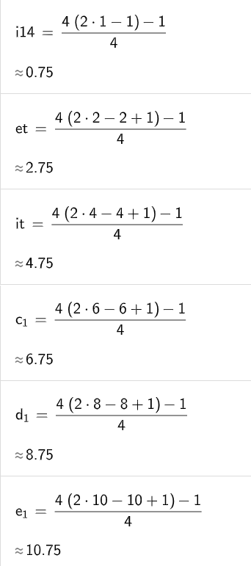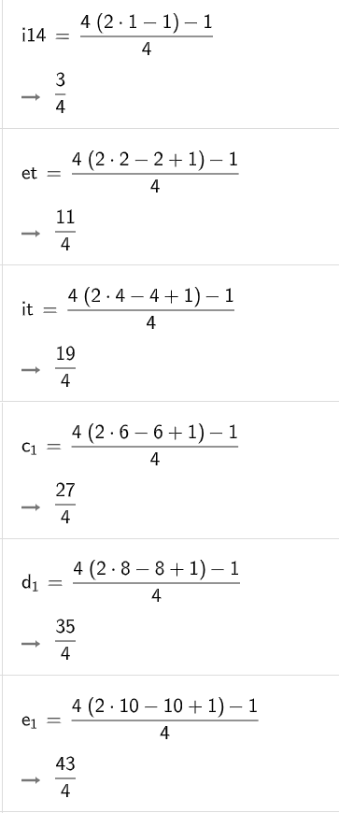Where start point in this example is g1 = 3/4

In imaginary unit Circle the start fixed point will be at 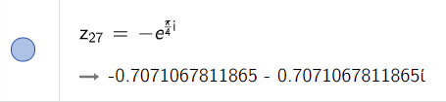

And every 8 steps we are going to go back to this exact imaginary point gain after one full circle on the non-imaginary Circle

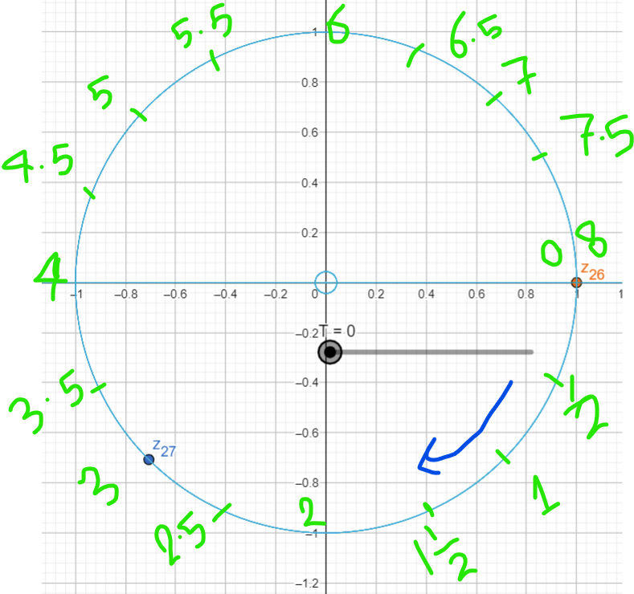

Will reach exact start point (Z27) for division with D = 4 at our formula (i14) fraction nominator value

T = 3

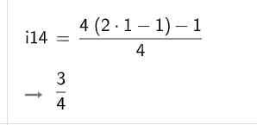

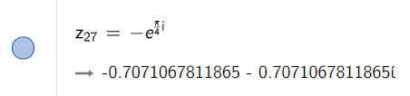

Next time pass over point Z27 will be at T = T + 8 = 3 +8 = 11

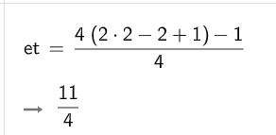

Next time pass over point Z27 will be at T = T + 8 = 11 +8 = 19

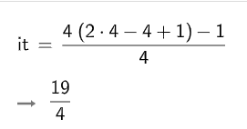

Point (1):

For Division by D

Start point will be at [ ] at T = [D-1] with (pass over) step = 2 \* D.

For our previous two examples

For D =2 start point will be at [ ] at T = [1] with (pass over) step = 2 \* 2 = 4.

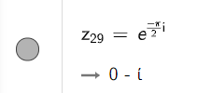

For D =4 start point will be at [ ] at T = [3] with (pass over) step = 2 \* 4 = 8.

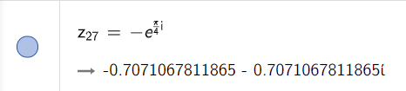

Example (3): D = 5; we Divide Circle by 2 \* 5 = so one cycle for (pass over) step to reach same start point will be = 10

Applying the formula so we get these points with step difference = 10.

One note here the values of the formula will be start point {+2, +4, +6, +8, +10, +12, ….}

Where start point in this example is g1 = 4/5

For D =5 start point will be at [ ] at T = [4] with (pass over) step = 2 \* 5 = 10.

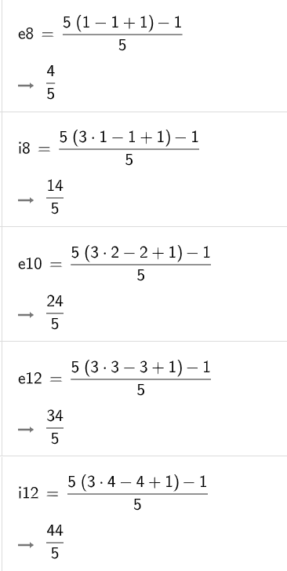 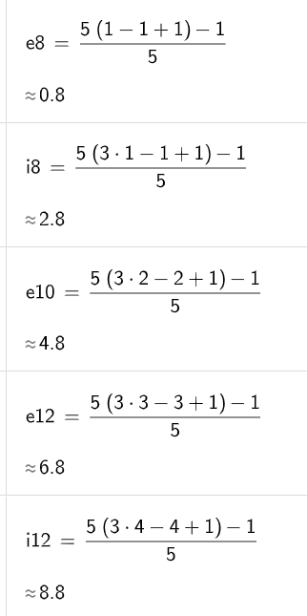

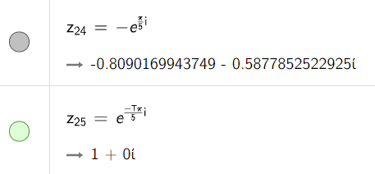 at T = 0

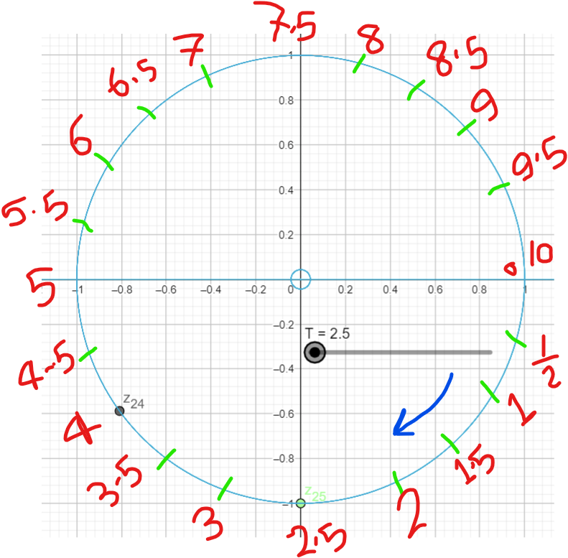

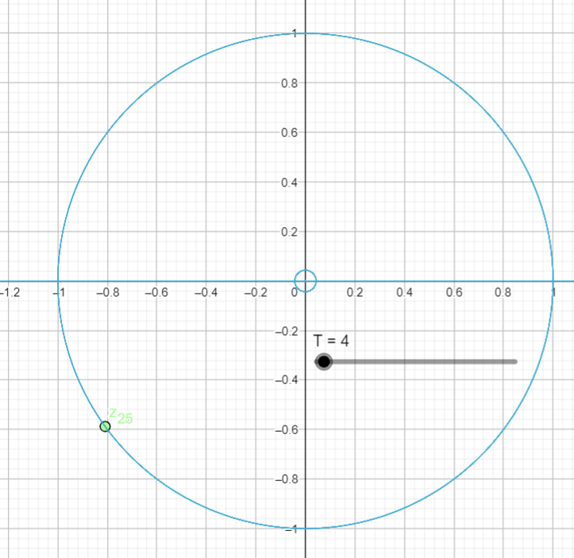

Point (2):

For Odd Divisions D = odd number

imaginary Circle [-i] all the time will be at D/2

imaginary Circle [i] at D = 5; will be at [3\*D/2]

imaginary Circle [1] at D = 5; all the time will be D \* 2^N

Imaginary Circle [-1] at all the time will be D \* (2^N+1)

Example (4): D = 7; we Divide Circle by 2 \* 7 = so one cycle for (pass over) step to reach same start point will be = 14

Applying the formula so we get these points with step difference = 14.

One note here the values of the formula will be start point {+2, +4, +6, +8, +10, +12, ….}

Where start point in this example is = 6/7

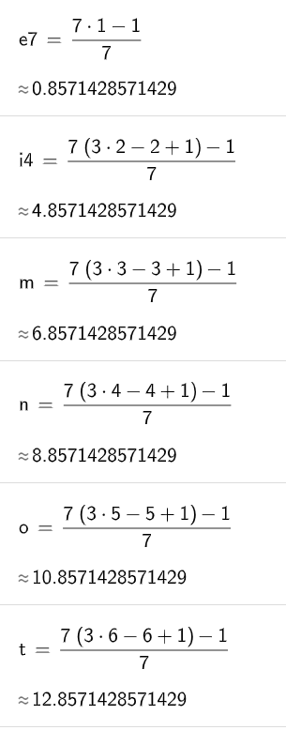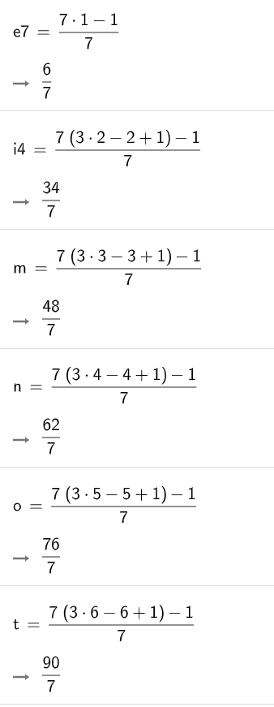For D =7 start point will be at [ ] at T = [6] with (pass over) step = 2 \* 7= 14.

at T = 6

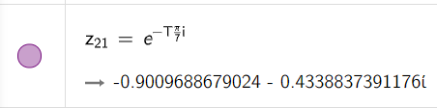

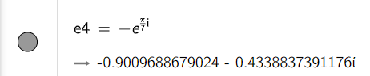

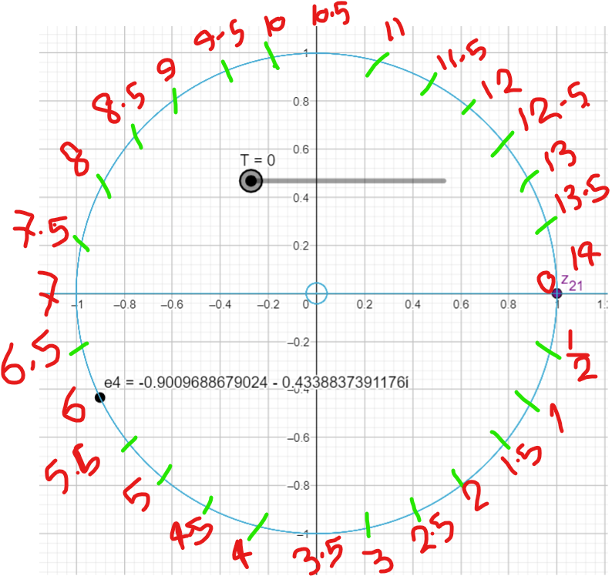

For Odd Divisions D = odd number

imaginary Circle [-i] all the time will be at D/2

imaginary Circle [i] at D = 7; will be at [3\*D/2]

imaginary Circle [1] at D = 7; all the time will be D \* 2^N

Imaginary Circle [-1] at all the time will be D \* (2^N+1)

Start Point at D -1 at Division = 6 i.e., we divide the angel between Z21 at Zero and e4, into 12 equal angels and this will be our angel in non-imaginary Circle

Point (3): angel in non-imaginary Circle = =

for D = 7 we need to divide 180 by 14 θ = = and if divide 360 by 14 θ = =

for D = 5 we need to divide 180 by 10 θ = = and if divide 360 by 10 θ = =

for D = 9 we need to divide 180 by 18 θ = = and if divide 360 by 18 θ = =

for D = 11 we need to divide 180 by 22 θ = = and if divide 360 by 22 θ = =

for D = 13 we need to divide 180 by 26 θ = = and if divide 360 by 26 θ = =

for D = 17 we need to divide 180 by 34 θ = = and if divide 360 by 34 θ = =

for D = 19 we need to divide 180 by 38 θ = = and if divide 360 by 38 θ = =

for D = 23 we need to divide 180 by 46 θ = = and if divide 360 by 64 θ = =

This means that after each (D \* θ) we are going to reach Zero at θ = 180 (Sin (180) = -1) at X = -1.

Or after (D\* θ/2) we are going to reach imaginary part only and real part will be Zero at θ = 90 and X = 0 (Cos (90) = 0)

Or we can say that = 180, for all values of D.

So for any Divisions [D] even or odd it will reach Zero at X = -1 and Sin(180).

Example (5): D = 13; we Divide Circle by 2 \* 13 = so one cycle for (pass over) step to reach same start point will be = 26

Applying the formula so we get these points with step difference = 26.

One note here the values of the formula will be start point {+2, +4, +6, +8, +10, +12, ….}

Where start point in this example is = 12/13

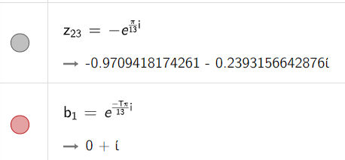For D =13 start point will be at [ ] at T = [12] with (pass over) step = 2 \* 13= 26

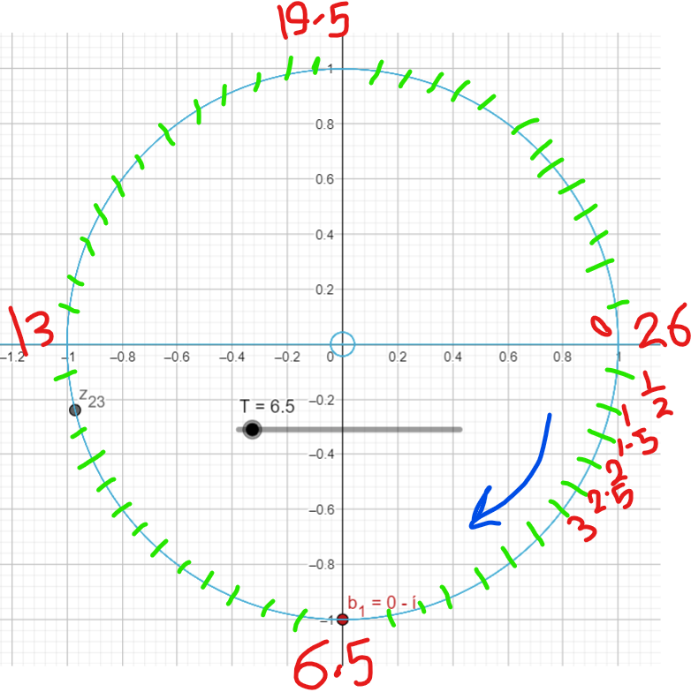

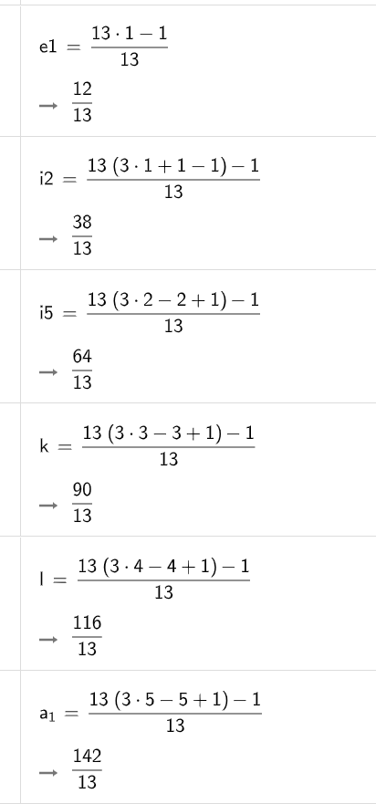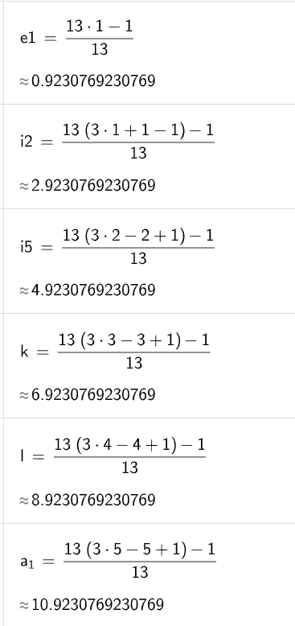

Example (6): D = 11; we Divide Circle by 2 \* 11 = so one cycle for (pass over) step to reach same start point will be = 22

Applying the formula so we get these points with step difference = 22.

One note here the values of the formula will be start point {+2, +4, +6, +8, +10, +12, ….}

Where start point in this example is = 10/11

For D =11 start point will be at [ ] at T = [10] with (pass over) step = 2 \* 10= 20

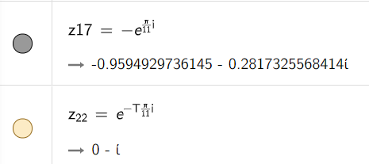

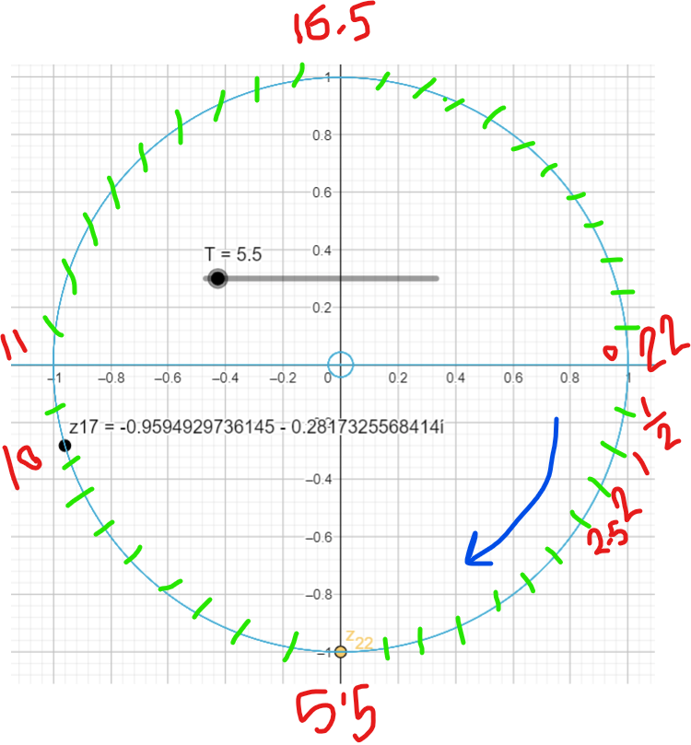

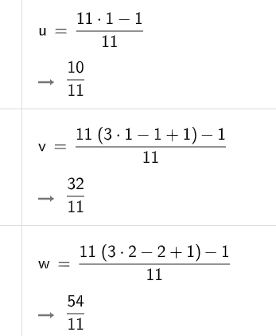 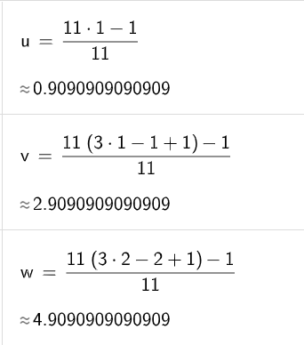

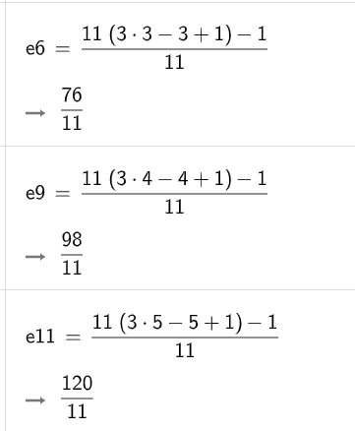 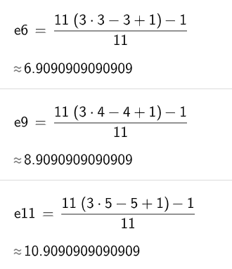

1. Any unit Circle non-imaginary can be divided into D divisions, where D is any natural number.
2. For Any Division D we will reach Zero at X =0 and Sin (180) for even or Odd divisions.
3. Imaginary unit Circle matches non-Imaginary unit Circle at 4 important points

complex number with imaginary part [-i] all the time will be at D/2

complex number with imaginary part [i] will be at [3\*D/2]

complex number with real part =[1] at D Partitions; all the time will be D \* 2^N

complex number with real part [-1] at all the time will be D \* (2^N+1)

1. Start point will be at [ ] at T = [D-1] with (pass over) step = 2 \* D.
2. Start Point will be at D-1.
3. Start point will be 2 \* θ before D reaches 180 at X = -1
4. Odd/even Divisions will be at [-i] at [D/2] on unit Circle
5. Odd/even Division will be at [i] at [3\*D/2] on unit Circle
6. Odd Divisions at [-i] and [i] imaginary part only at